Drinks

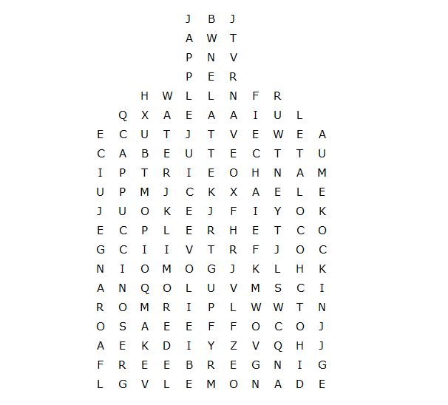

Hot chocolate orange juice ginger beer apple juice
cappuccino lemonade smoothie earlgrey coffee
fanta water latte wine coke milk coke tea

Drinks – solution

